**1. Introduction**

**This document explains how we’ll analyze a dataset to discover useful insights that can support smarter business decisions.**

**The goal is to ask key questions and use tools like SQL and Python (especially libraries like pandas and Matplotlib) to explore the data. These tools help us find trends, patterns, and relationships that may not be obvious at first glance.**

**In short, we’re turning raw data into clear information that can guide strategy and improve performance.**

**1- Which product types generate the highest revenue?**

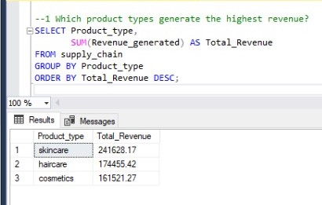

**2-What are the top-selling products in terms of revenue or quantity?**

**3-What is the relationship between the number of products sold and stock levels for each product type?**

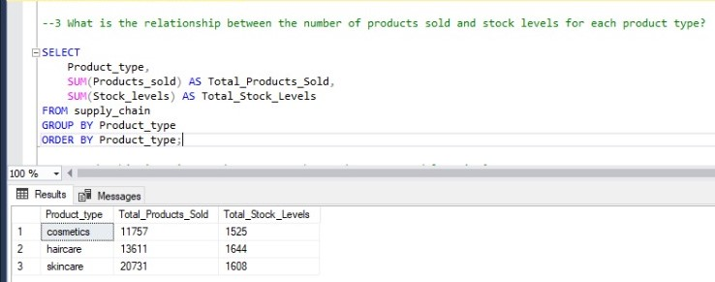

**4-How do shipping times and costs vary by product type and location?**

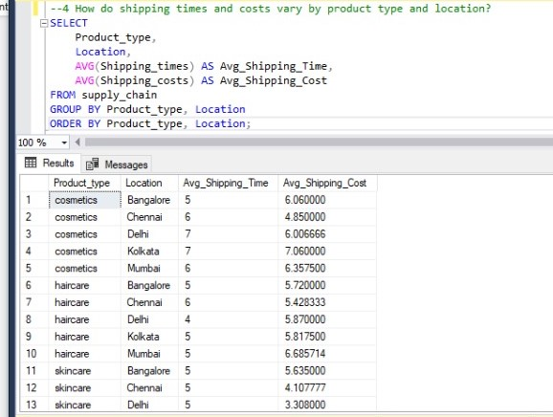

**5- What are the most common defect rates for each product type and their impact on revenue?**

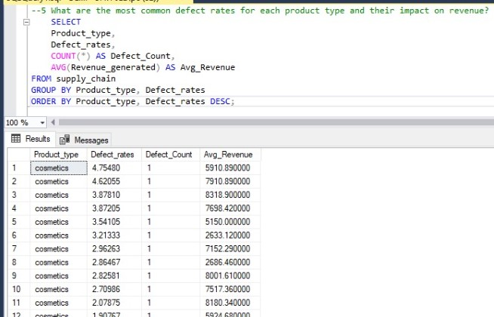

**6-How does availability influence of products sold across different product types?**

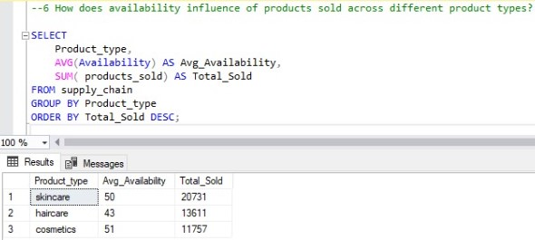

**7-How do lead times and shipping times affect sales performance?**

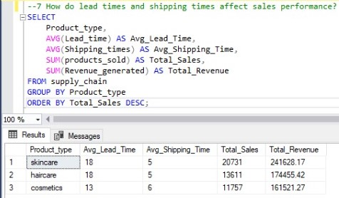

**8-Which Gender are associated with higher purchase volumes and revenues?**

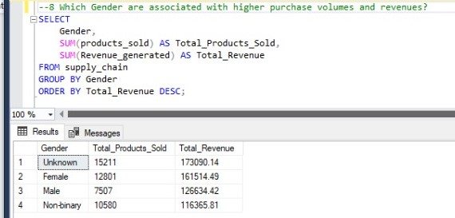

**9-How does customer gender affect product preference and purchasing patterns?**

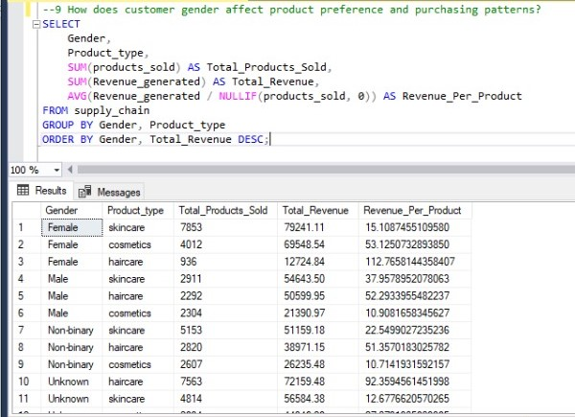

**10-What are the sales trends based on customer Gender?**

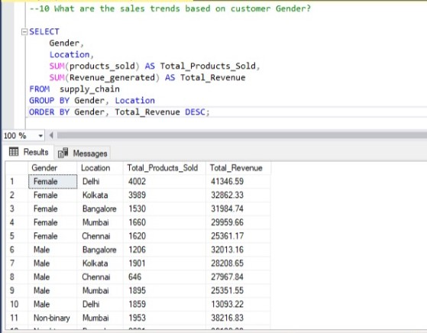

**11-How do customer Gender influence purchasing behavior?**

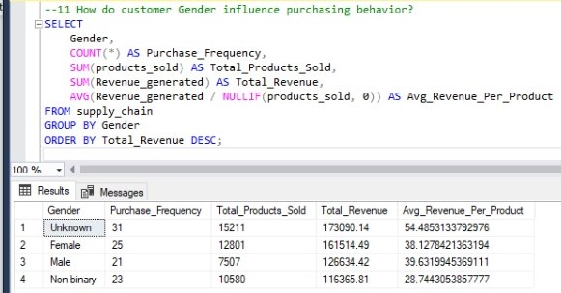

**12-Which suppliers have the shortest lead times and lowest manufacturing costs?**

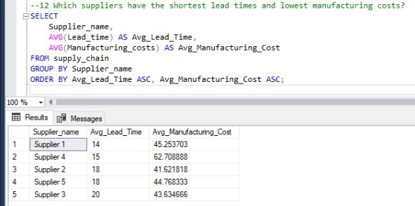

**13-How do production volumes vary by supplier and location?**

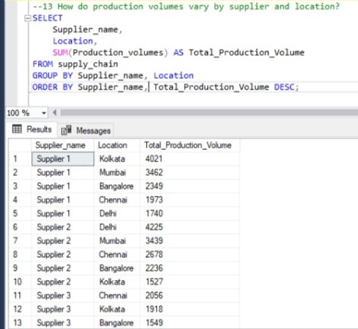

**14-What are the average shipping costs and times for each transportation mode?**

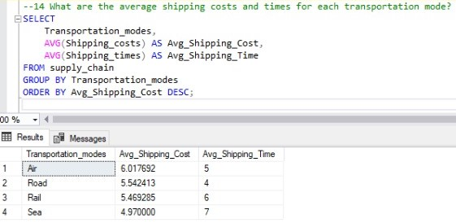

**15-How do shipping carriers affect shipping times and costs?**

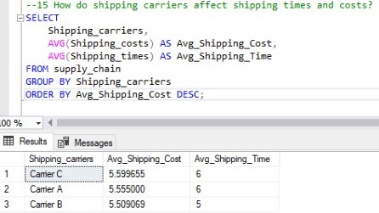

**16-Which transportation modes are associated with the lowest costs and fastest delivery times?**

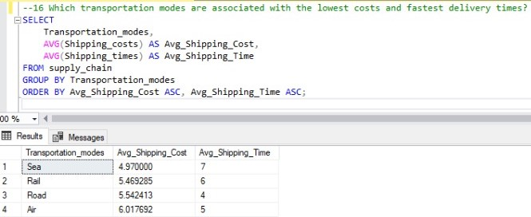

**17-Evaluate supplier performance according to lead time**

**18-Inspection results for each category**

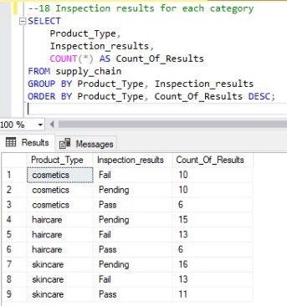

**7. Conclusion**

**This analysis gave us a clear and detailed understanding of the dataset. By using tools like SQL and Python libraries, we were able to extract, clean, and explore the data effectively. The insights we discovered can help guide smarter decisions and support the organization’s strategic goals.**